
Import of Classification Data
from csv-file
- For New Zealand Sites -

© Eagle Datamation International Pty Ltd
• Level 2, 184 Bourke Road Alexandria NSW Australia
• Phone 61 2 9025 1100 • Fax 61 2 9025 1199 • training@edi.com.au

Table of Contents

1 Introduction 1
1.1 Important Remarks 1
1.2 Importing Product Data 1
2 File Specification 3
2.1 Generic Attributes of csv-Data Import Files 3
2.2 File Specification 3

Introduction

ediEnterprise has the capability to import Classification Lookup data from a csv-file. This document describes the standard file format for import of Classification Lookup data for New Zealand ediEnterprise sites.
The data can be imported into ediEnterprise using the option Config → Customs Files → Classification → Export/Import → Import from Excel (.csv).

Important Remarks

It is essential that you strictly follow the file specification described in this document. If you would like to import Classification Lookup data in a different file format, customer-specific programming will be necessary. This would be chargeable programming and require a quotation.

- Each Classification Lookup Code in the csv-file will be added as a new record in ediEnterprise. The data import procedure will not merge any Classification Lookup Codes.

- The system will not import Classification Lookup Codes that already exist in ediEnterprise. The system will display all Classification Lookup Codes that have been excluded from the data import for this reason. The operator may print the list.

Importing Classification Data

Select Config → Customs Files → Import Classification or Export Classification → Export/Import → Import From Excel (.csv) to import of Classification Lookup data from a csv-file as per file specification below.
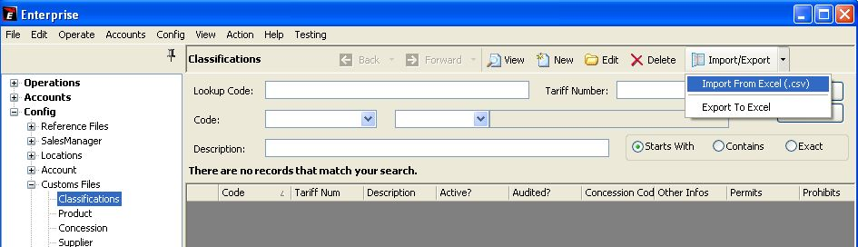

The system will prompt you:
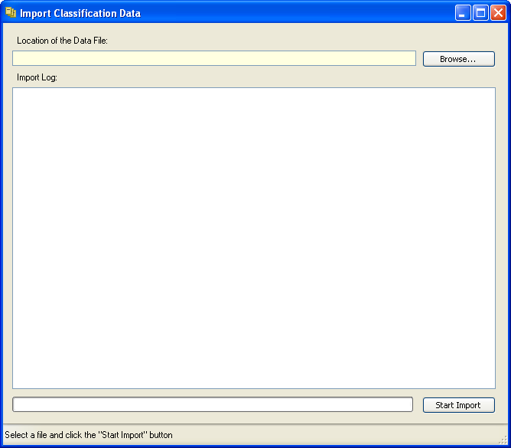

Enter the file location and name. Then press the [Start Import] button to import the Classification Lookup data.

System Prompt after pressing the <Start Import> button:
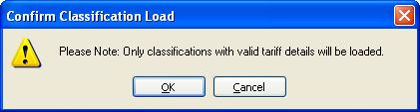

System Logging, if the File Header is incorrect:
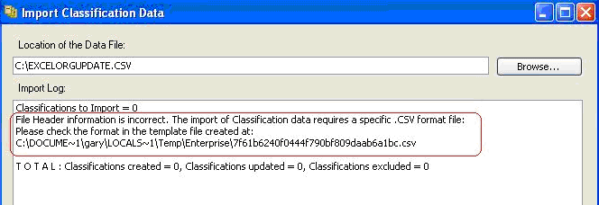

Open the sample csv-file created by the system. It shows the required file format and column headers.

System Logging showing errors that may occur:
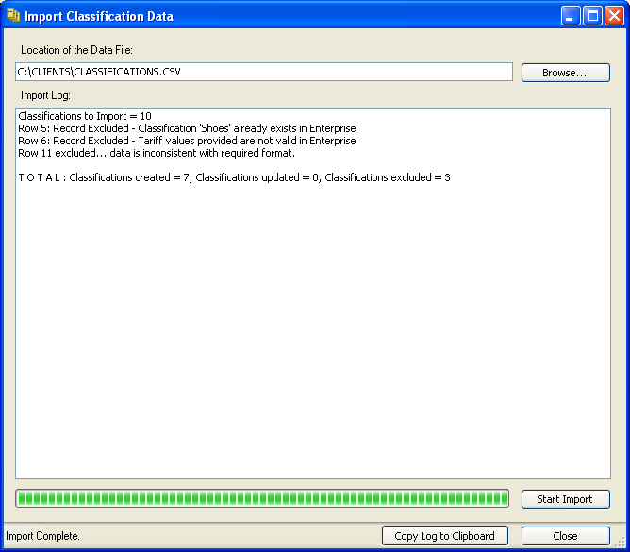

File Specification

Generic Attributes of csv-Data Import Files

The following applies to the standard ediEnterprise data import files in csv-file format:
- The file format is csv-file.
- The first line of the file must be the header line. It must contain the headers in exactly the same spelling as per file specification below. Otherwise the data will not be imported.
- It is essential that you provide all columns in the order as listed in the file specification. Do not add any additional columns or omit any columns. Otherwise the data will not import.
- Leave non-mandatory fields blank, if you cannot provide the data.
- Date fields are 8 characters in the form YYYYMMDD. No separators are allowed.
- Boolean fields are character “Y” = True or character “N” = False.
A blank boolean field is interpreted as “N”.
The system validates the header of each column to determine whether the file structure matches the standard. If the number of columns differs or the column headers are spelt differently, the data will not import.

Tip: Create a template csv-file in the required file structure by importing a file in an invalid format. The system will reject data import and create a file template with the correct column headers. You can then use this template to structure your data import file.

File Specification
Legend:
Col Column
Type A = alphanumeric
N = numberic
B = Boolean
M = mandatory
C = Conditional

Col | Header | Type | M | Remarks
 | Code | 35 A | M | Lookup Code.  ediEnterprise works with alpha-numeric Classification Lookup codes that are linked to Tariff Items. The users will enter these Lookup codes when they classify Products or Invoice Lines for Customs Entries. If your company does not work with Lookup codes, please duplicate the Tariff as per column 3.
 | Description | 80 A |  | Classification Code Description.  If this field is left blank, the generic tariff description, based on the first 4 characters of the Tariff Item, will be used. For example, if the Tariff Item was “0406.90.00.11”, the description for “0406” would be used.
 | Tariff | 14 A | M | Tariff Item.  Import Classification Code: Provide Tariff Item including Stat Code, e.g. “2203.00.31 15” or “2203003115”.  Export Classification Code: Provide the Tariff Item, e.g. “2203.00.10” or “22030010”.
 | Concession | 7 A |  | Concession code, if applicable.
 | PartsOfTariff | 14 A |  | Part of Classification, if applicable.
 | PermitCode1 | 3 A |  | Permit Code 1, if applicable.
 | PermitNo1 | 12 A |  | Permit Number 1, if applicable.
 | PermitCode2 | 3 A |  | Permit Code 2, if applicable.
 | PermitNo2 | 12 A |  | Permit Number 2, if applicable.
 | PermitCode3 | 3 A |  | Permit Code 3, if applicable.
 | PermitNo3 | 12 A |  | Permit Number 3, if applicable.
 | ProhibitedCode1 | 3 A |  | Prohibited Code 1, if applicable.
 | ProhibitedCode2 | 3 A |  | Prohibited Code 2, if applicable.

